Hospital Community Benefits - Community Representative Feedback Form

Instructions: You have been asked to complete this form based on your role as a community representative with whom a hospital has engaged in developing its Community Health Needs Assessment and/or Implementation Strategy. Please submit a copy of the completed form to the hospital (please see the hospital’s most recent Community Benefits report for contact information) and to the Attorney General’s Office (at CBAdmin@state.ma.us).

- Background Information
- Your Name
Click or tap here to enter text.

- If You Represent an Organization, Name of Organization and Your Position
Click or tap here to enter text.

- Name of Hospital
Click or tap here to enter text.

- Are you a member of the hospital’s Community Benefits Advisory Committee (CBAC)? ☐ Yes ☐ No
  - If no, please briefly describe your involvement in the hospital’s Community Benefits process.
Click or tap here to enter text.

- Level of Engagement Across CHNA and/or Implementation Strategy
Please use the spectrum below from the Massachusetts Department of Public Health to assess the hospital’s level of engagement with the community.

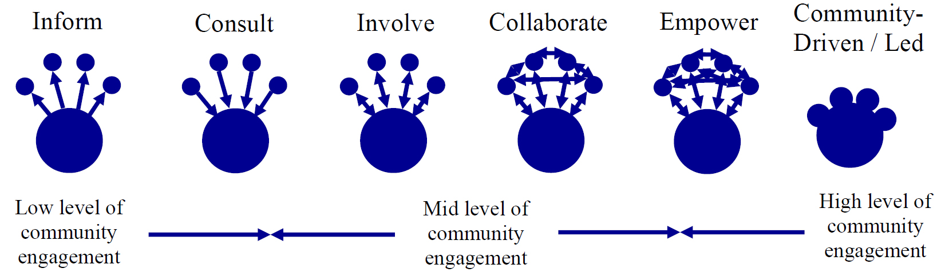

- Community Health Needs Assessment:
Based on your knowledge and experience, please assess the hospital’s level of engagement with the community in developing its Community Health Needs Assessment (“CHNA”). If your knowledge and/or experience do not encompass a particular category, please select “N/A” from the drop-down menu.
Category | Level of Engagement
Overall engagement in assessing community health needs | Choose an item.
Defining the community to be served | Choose an item.
Establishing priorities | Choose an item.

- Implementation Strategy:
Based on your knowledge and experience, please assess the hospital’s level of engagement with the community in developing and implementing its plan to address the significant needs documented in its CHNA. If your knowledge and/or experience do not encompass a particular category, please select “N/A” from the drop-down menu.
Category | Level of Engagement
Overall engagement in developing and implementing hospital’s plan to address significant needs documented in CHNA | Choose an item.
Selecting Community Benefits programs | Choose an item.
Implementing Community Benefits programs | Choose an item.
Evaluating progress in executing Implementation Strategy | Choose an item.

- Engagement Experience
Please indicate the degree to which you agree or disagree with the following statements:
 | Strongly Agree | Agree | Neutral | Disagree | Strongly Disagree | N/A
When the CBAC comes together, I feel comfortable sharing my opinion | ☐ | ☐ | ☐ | ☐ | ☐ | ☐
I am satisfied with my/my organization’s participation in this process | ☐ | ☐ | ☐ | ☐ | ☐ | ☐

- What is an example of a community engagement strategy by the hospital that has worked well over the past year?
Click or tap here to enter text.

- What change, if any, would you most like to see in your engagement going forward?
Click or tap here to enter text.

“Community Engagement Standards for Community Health Planning Guideline,” Massachusetts Department of Public Health, available at: http://www.mass.gov/eohhs/docs/dph/quality/don/guidelines-community-engagement.pdf. For a full description of the community engagement spectrum, see page 11 of the Attorney General’s Community Benefits Guidelines for Non-Profit Hospitals.

